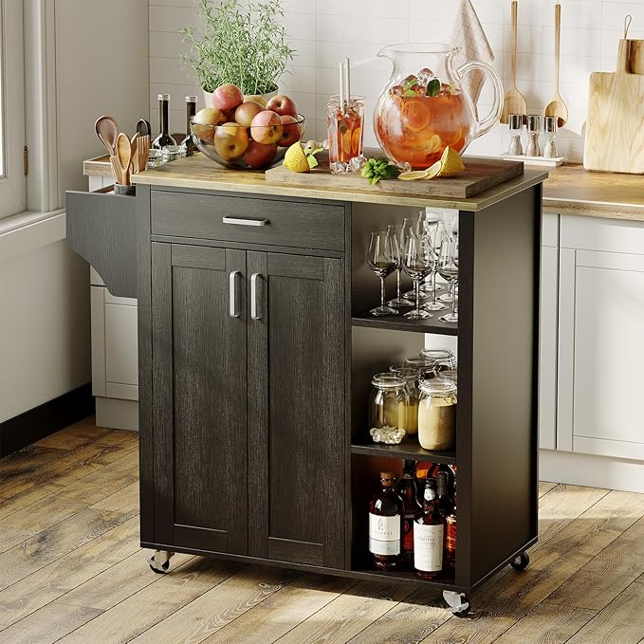

$366

Mobile Rolling Island Cart for Kitchen, Kitchen Island on Wheels with Spice Rack& Drawer & Open Shelves & Towel Rack, Microwave Cart for Kitchen, Dining Room, 34.84" x 18.89" x 37"